Computer Networks Laboratory Week 3

Name : Tanishq Vyas
SRN : PES1201800125
Section : H
Semester : 5
Branch : CSE

When we have some binary data that we want to ship across a network, we don't do it by just streaming the bits and bytes over the wire in a raw format. Some media are made for streaming text. Since some protocols may interpret our binary data as control characters (like a modem), or our binary data could be screwed up because the underlying protocol might think that you've entered a special character combination (like how FTP translates line endings).
So to get around this, people encode the binary data into characters. Base64 is one of these types of encodings.
We use base 64 Because you can generally rely on the same 64 characters being present in many character sets, and you can be reasonably confident that your data's going to end up on the other side of the wire uncorrupted. The same is used to encrypt the password for the authentication using the Base64 rules.

Password Authentication :

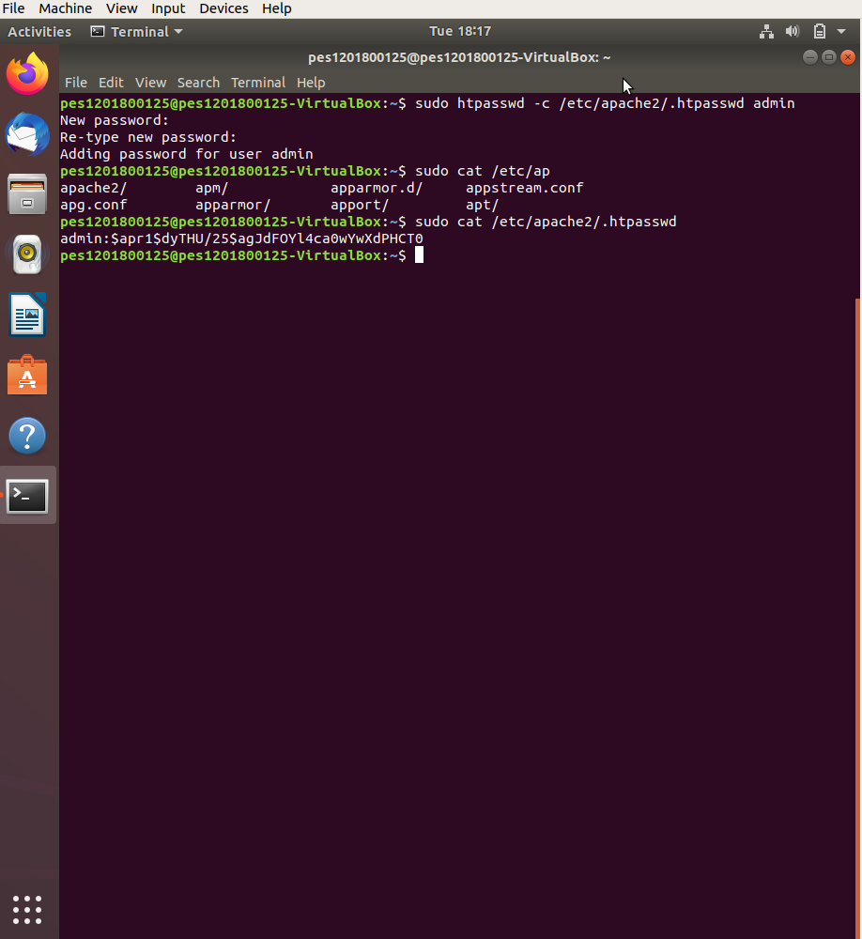

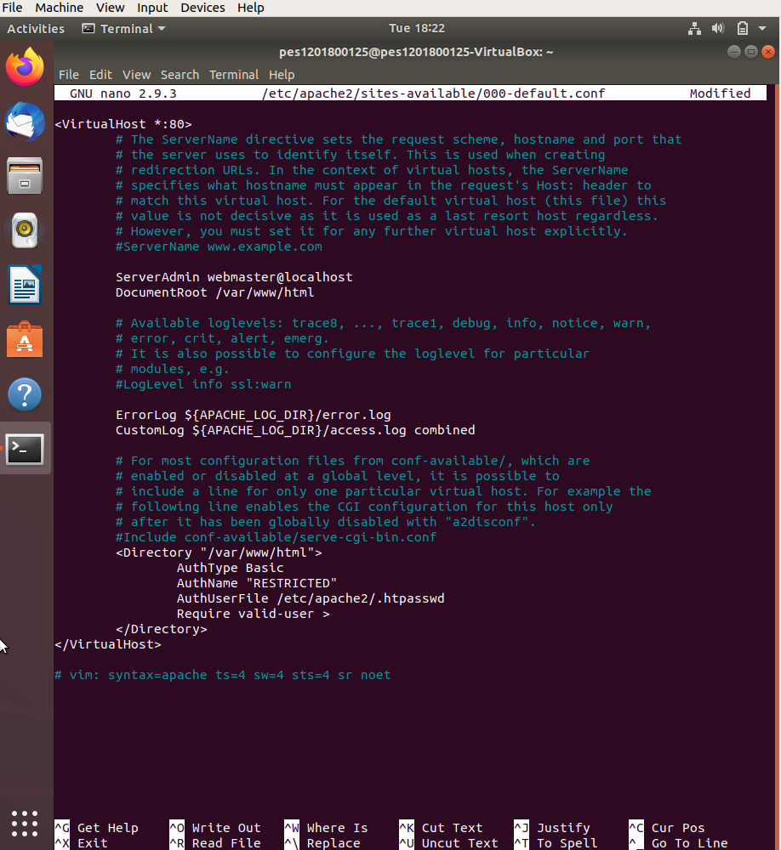

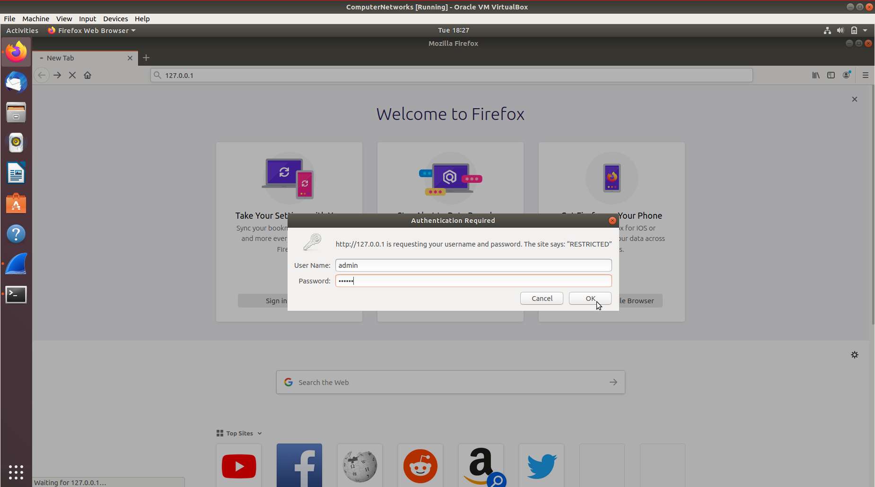

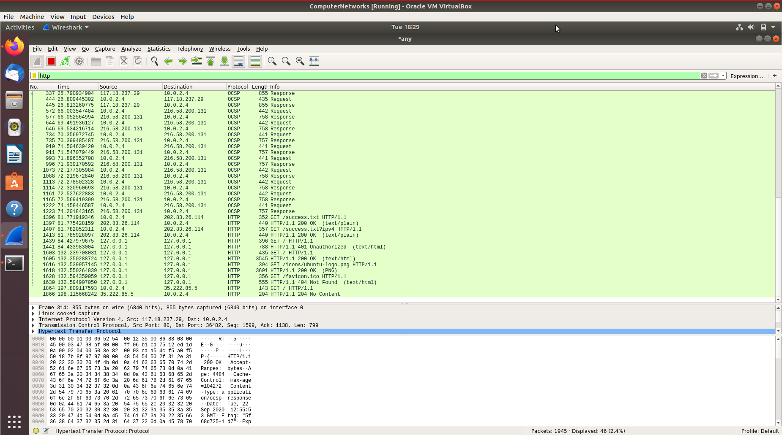

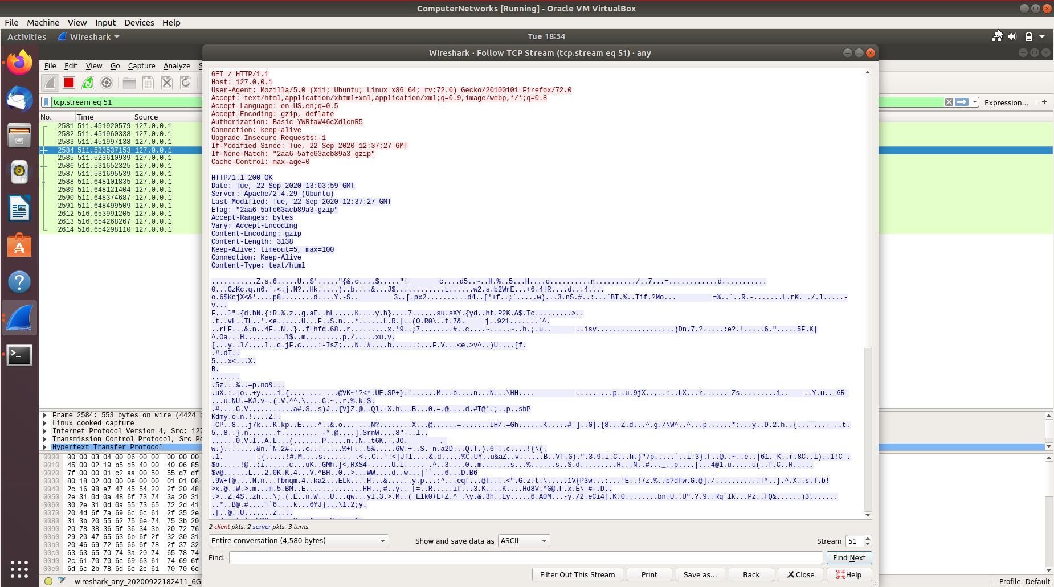

Cookie Setting :

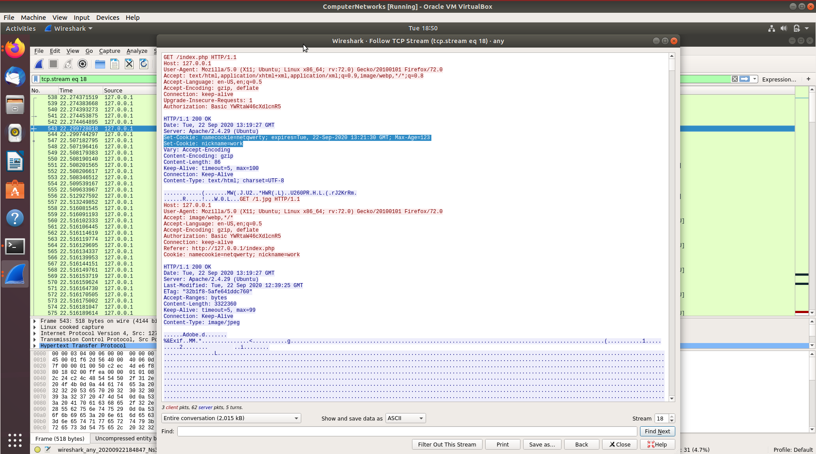

Conditional Get: If-Modified-Since :

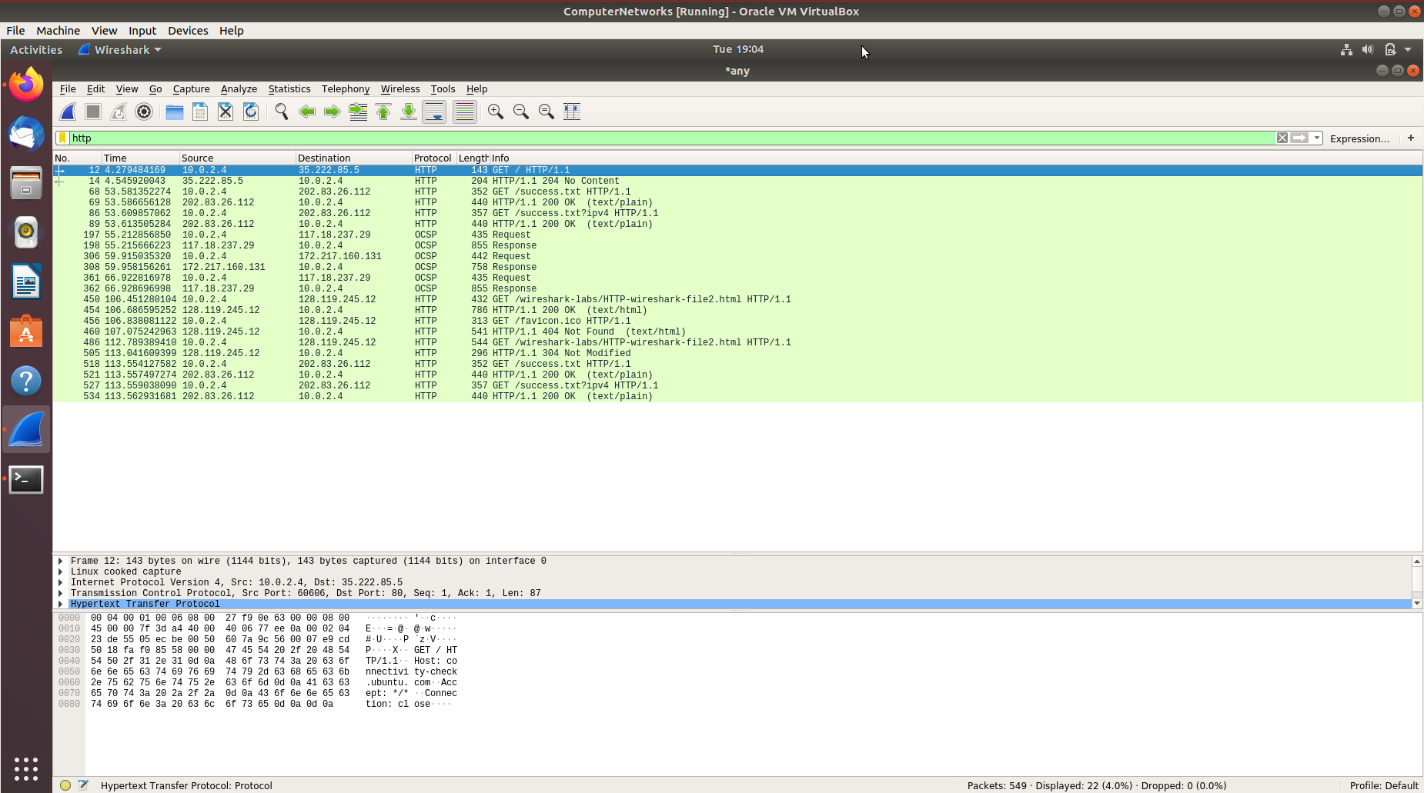
Request Capture for http://gaia.cs.umass.edu/wireshark-labs/HTTP-wireshark-file2.html

Que 1. Inspect the contents of the first HTTP GET request from your browser to the server. Do
you see an “IF-MODIFIED-SINCE” line in the HTTP GET?

Ans 1. No, we do not see and “IF-MODIFIED-SINCE” line in the HTTP GET request.

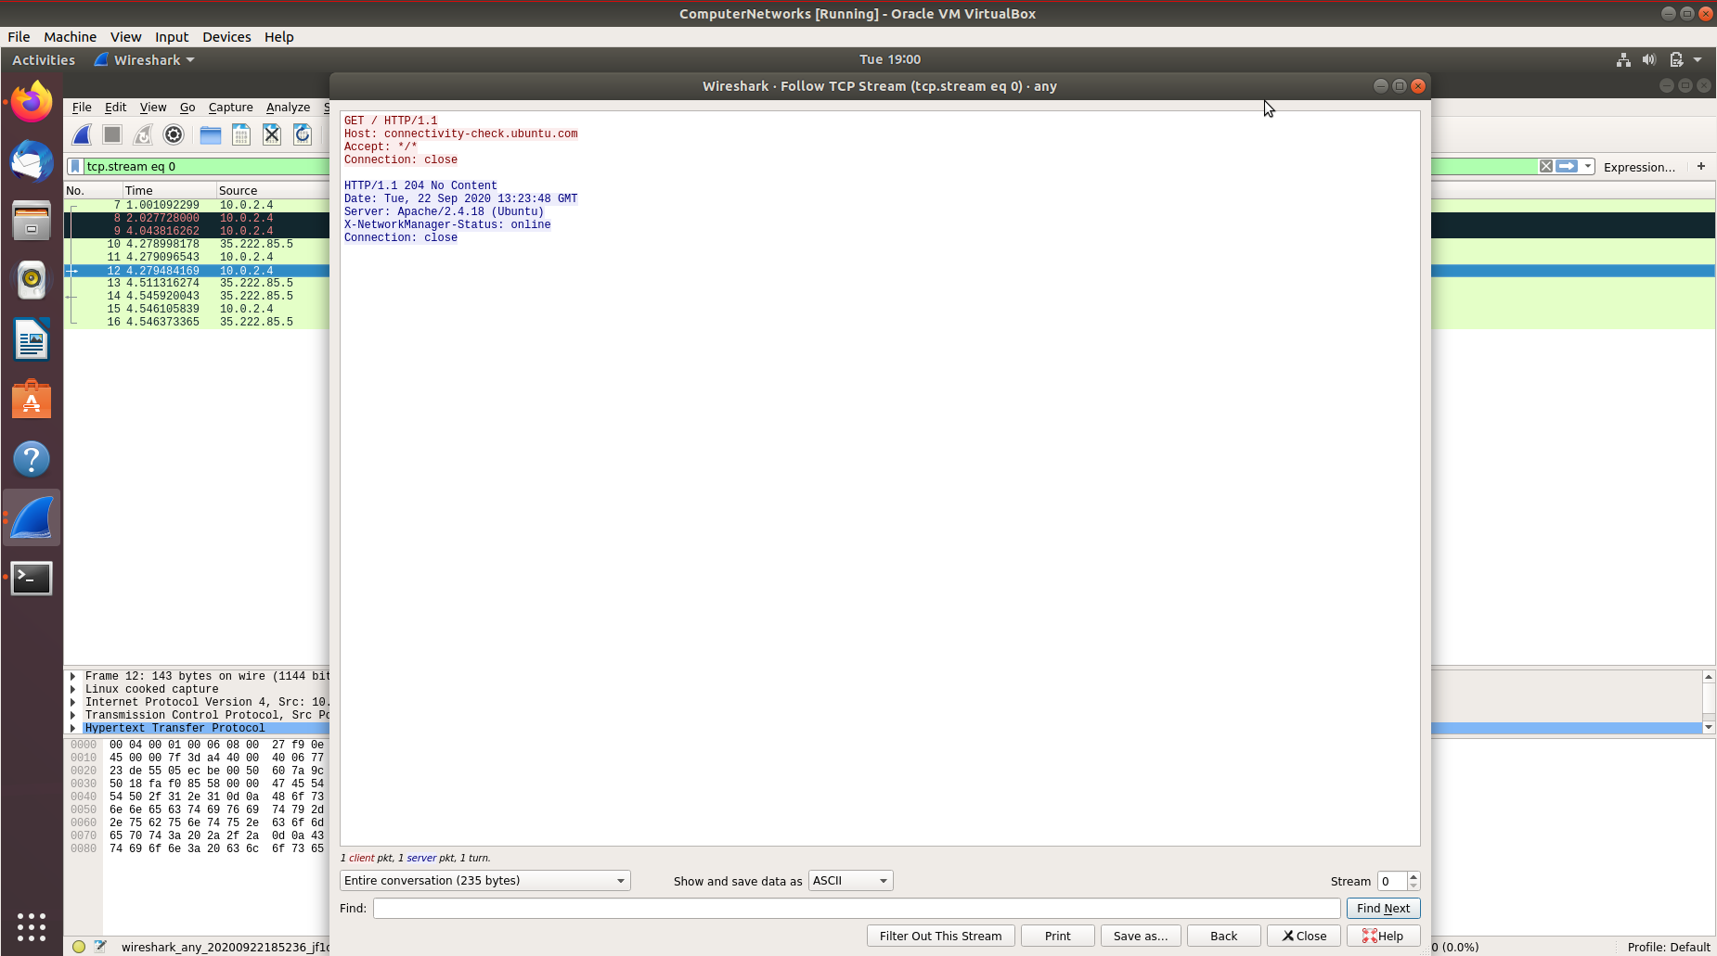

Que 2. Inspect the contents of the server response. Did the server explicitly return the contents of
the file? How can you tell?

Ans 2. No, the server did not return any contents of the file. We can tell this by seeing the resppnse header which reads No Content.

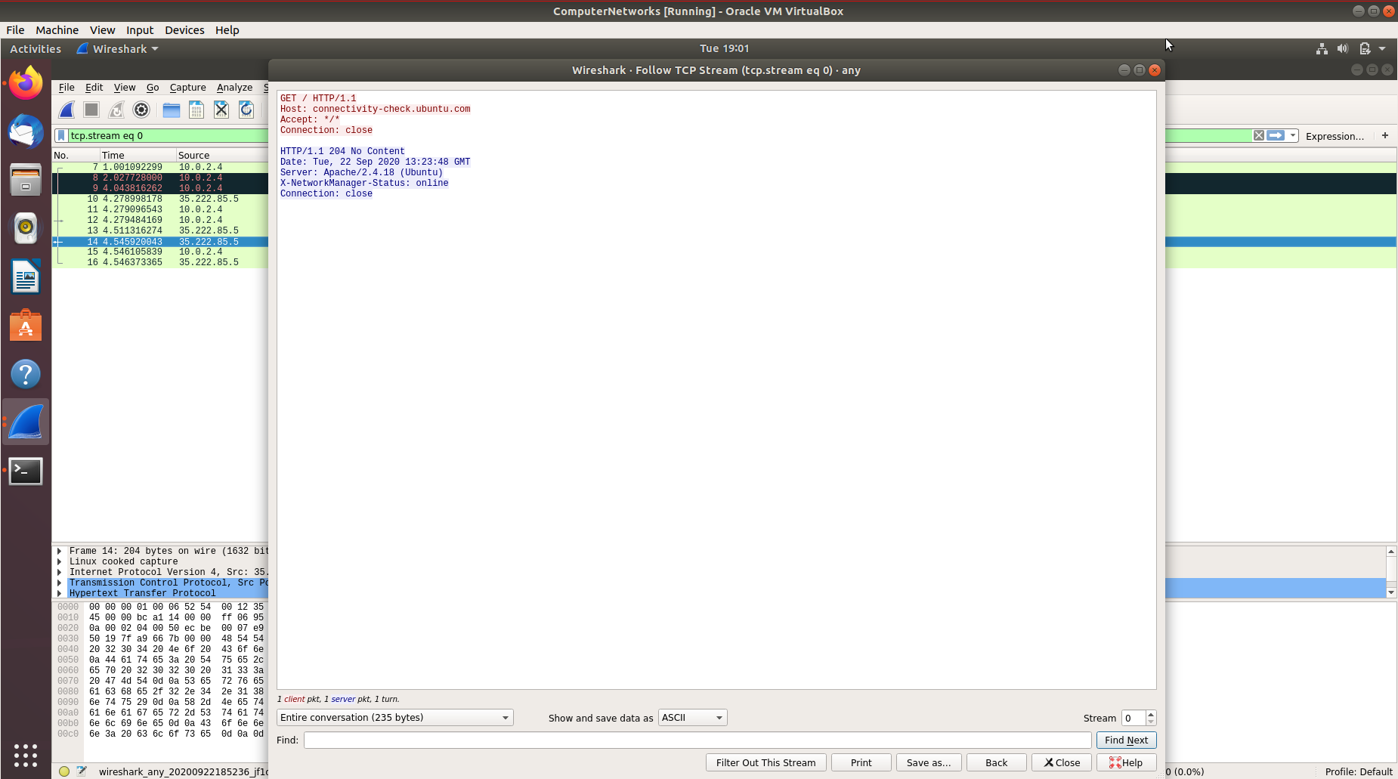

Que 3. Now inspect the contents of the second HTTP GET request from your browser to the
server. Do you see an “IF-MODIFIED-SINCE:” line in the HTTP GET? If so, what
information follows the “IF-MODIFIED-SINCE:” header?

Ans 3. No, I do not see and “IF-MODIFIED-SINCE” header. But we do have a Last-Modified header in its response, which tells us the date of last modification

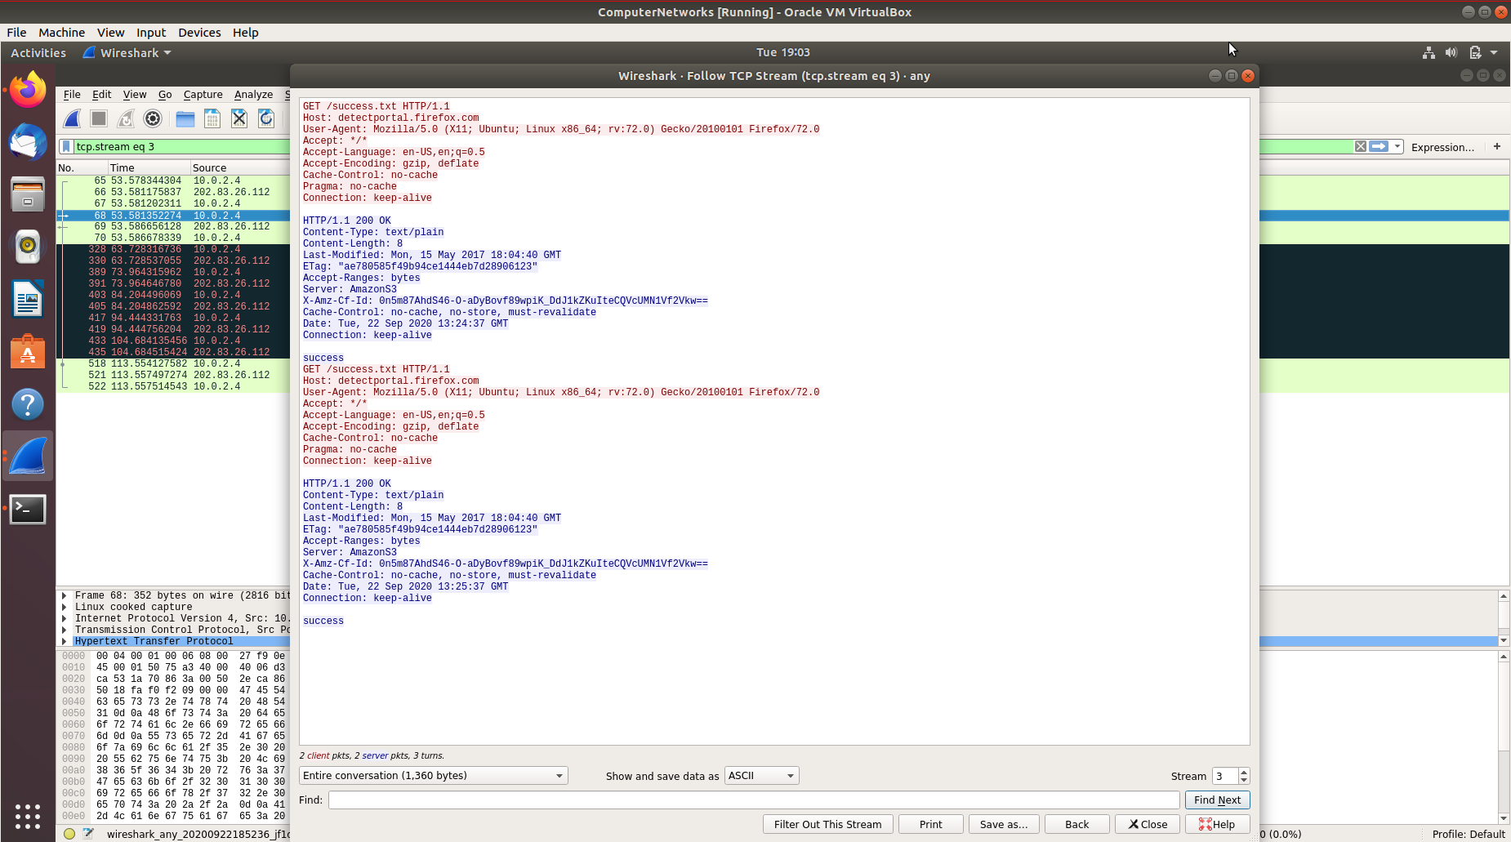

Que 4. What is the HTTP status code and phrase returned from the server in response to this
second HTTP GET? Did the server explicitly return the contents of the file? Explain

Ans 4. Statuis code is 200 and phrase is ok. Yes, the server explictily returned the contents of the file as we can see a content-type header along with the corresponding length header.

